CUSTAR COMMUNITY NEWSLETTER
FALL 2021 EDITION

UPCOMING EVENTS
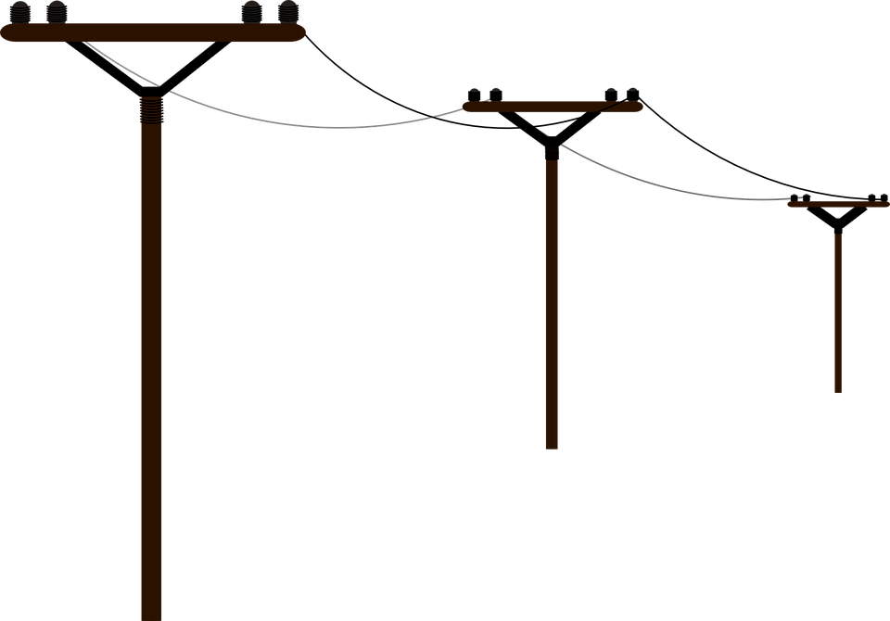
CUSTAR ELECTRIC DEPT/
BOARD OF PUBLIC AFFAIRS

President Jerry Clink
Vice President Dave Wensink
Board Member Deb Bechstein
Clerk Barb Clink

For questions, electrical hookup,
or repairs, call 419-669-3537

- Our 3rd annual Harvest Party is planned for Saturday, September 25th at Louy Park. Several fun activities are scheduled throughout the day, with the potluck meal starting at 5pm. See reverse side for more details.
- Trick-or-Treat night will be Sunday, October 31st from 6:00-7:30pm.
- Election Day is Tuesday, November 2nd. Residents can vote at Sonlight Church in Weston (19920 Sand Ridge Rd) from 6:30a-7:30p.
- The Bookmobile will be in Custar every other Monday this fall (9/27, 10/11, 10/25, 11/8, & 11/22) from 3:15-4:00pm in the lot of F & M Bank.
- The Custar United Methodist Church will hold their Soup Supper on Wednesday, October 27th from 4:00pm until gone. You'll be able to drive through and get your choice of soup(s), plus hot dogs/chili dogs. Free will donations will be accepted.
- The Village is planning another Christmas decoration/lighting contest again this holiday season for residents of the Village. Details will be posted to Facebook when available.

Thank you to everyone who has been so faithfully stocking and restocking the new food pantry located at the recycling building. We appreciate that St. Louis Church has started this service for those in the area to use when in need.

VILLAGE REMINDERS

LIGHTNING & THUNDERS TAVERN
419-669-3576

Open at 8am for Breakfast
Taco Thursdays, 5-8pm
$1 Burgers on Tuesdays

KARAOKE every other Saturday from 7-10p

Basic grocery items are also for sale here at any time.

- OPEN BURNING: While contained campfires are fine, other burning (especially of plastic, petroleum products, rubber tires, furniture, and misc trash) is strictly prohibited within Village limits. To report these instances, please call the Sheriff’s office at 419-354-9001.
- GRASS/WEEDS: Keep in mind that Village ordinance requires yards to be mowed & weeds/grass kept under 8” in height.
- SNOW: Please be advised that vehicles are to be removed from the established “Snow Emergency Route” (consisting of Custar Road & Route 281) within 2 hours of a snowfall of 2” or more. This allows for our plow truck to safely clear the streets in a timely fashion. Additionally, we appreciate your help in keeping sidewalks shoveled and clear.

Be sure to like & follow our Village of Custar, Ohio page on Facebook.
Here we will post events, photos, reminders, updates, & other info.

There will be TWO OPEN COUNCIL SEATS in January of 2022. If you’ve ever wanted to serve your community in this capacity, this is your chance! Candidates must be registered to vote and have lived in the Village for at least one year.

For more information, visit our website at www.custarvillage.org. Also feel free to attend Council’s monthly meetings, the 2nd Wednesday of every month at 7:30pm at the Legion Hall (9155 Custar Road). To contact the Village at any other time, send an email to custarvillage@gmail.com or call Mayor Rob Cavin at 419-614-4026.

THIS NEWSLETTER WAS BROUGHT TO YOU BY YOUR CUSTAR VILLAGE OFFICIALS:

Mayor Rob Cavin; Council President Renee Hartman; Fiscal Officer Sarah Schroeder
Village Council- Cheryl Vanscoder, Chad Dauster, Dee Bates, Dawn Berry, & Jeff Dauster
CUSTAR
3RD ANNUAL OLD-FASHIONED
Harvest Party & Potluck in the Park
Saturday, September 25, 2021
1:00-11:00pm at LOUY PARK

1:00pm CORN HOLE TOURNAMENT
Registration 12-12:45pm; $20 per team; CASH payout!

1:00-4:00pm KIDS GAMES, FACE PAINTING, & FUN FUN FUN!

2:00-7:00pm VENDOR FAIR
Come check out hand-made items from several local crafters.
(For vendor info, call 419-591-9114)

3:00-7:00pm HAY RIDES
Tickets can be purchased for $2.00/each.

5:00-7:00pm POTLUCK MEAL
We encourage you to bring older, home-made recipes or a special
family dish. Hot dogs will be provided.
DUKE’S SMOKE WAGON will also have BBQ ribs & chicken for sale.

6:00-8:00pm CHRIS MT CASTLE & BAND “SPECIAL GUEST”
There will also be musicians playing throughout the park (all day).

8:00pm PUMPKIN PIE JUDGING (No need to pre-register)
Bring your homemade pumpkin pies!
Judging categories: 1) Appearance; 2) Texture; 3) Taste; 4) Special Remarks

8:00-11:00pm DJ/KARAOKE & BONFIRE
50/50 Raffle- Tickets will be on sale all evening!
Time for the ADULTS to cut loose!

ALL DAY TRACTOR SHOW
Hey Farmers! Come show off your tractor!

