CUSTAR COMMUNITY NEWSLETTER
SPRING 2021 EDITION

IMPORTANT DATES

Be sure to like & follow our Village of Custar, Ohio page on Facebook.
Here we will post events, photos, reminders, updates, & other info.
If you have historical Custar photos you would like to share, please send them to custarvillage@gmail.com so they can be posted.

- Spring Clean-up/Trash Disposal--- On May 1st, there will be 3 roll-off dumpsters located at the grain elevator on 281 (near the railroad tracks). Custar residents may dispose of any excess junk, garbage, old furniture, and pretty much anything else EXCEPT mattresses, tires, brush/yard waste, freon appliances, large electronics, oil, or paint. The containers will remain in place from 8am-4pm or until full. This service is available to Village residents ONLY; be prepared to provide proof of address.
- St. Louis School will be having a drive-thru Cinco De Mayo Dinner on Saturday, May 1st from 4-6:00pm (or until gone). Meals include a chicken burrito, Spanish rice, beans, & a dessert for a free-will donation.

- Custar’s Community Garage Sales will be on Friday, May 14th (9a-5p) and Saturday, May 15th (9a-2p). To get your sale on the map, FREE of charge, call Sarah Schroeder at 419-575-9217 before May 12th. Maps will be made available the Thursday before the sales (May 13th) at the Custar Tavern and F&M Bank. There will also be maps available at the individual sale locations. (Note: The Village of Milton Center will still be holding their garage sales on the last weekend of this month--- April 29, 30, & May 1).

- This year’s Brush Pick-up has been scheduled for Saturday, May 8th. Please have all brush to the curbside by 7am that morning. No tree stumps, boards/wood/building materials, or anything with a diameter greater than 4 inches will be accepted… and please NO ROSE BUSHES.

LIGHTNING & THUNDERS TAVERN
419-669-3576

Open at 8am for Breakfast
Taco Thursdays, 5-8pm
$1 Burgers on Tuesdays

KARAOKE every other Saturday from 7-10p

Basic grocery items are also for sale here at any time.

- Plans for the annual Memorial Day Parade are still being discussed.

VILLAGE REMINDERS
- CURFEW: Minors unaccompanied by an adult are not to be out during the following hours--- 10pm-6am Sunday-Thursday during the school year; and midnight-6am on Fridays & Saturdays and during the summer.
- OPEN BURNING: While contained campfires are fine, other burning (especially of trash) is strictly prohibited within Village limits. To report these instances, please call the Sheriff’s office at 419-354-9001.
- NUTS/GRASS CLIPPINGS: Section 94.10 of the Ohio Basic Code states that “no owner, occupant, or person having the care of any building or lot of land bordering on any street or sidewalk shall permit the same to encumbered with substances of any kind so as to interfere with the free and unobstructed use thereof.” Therefore, please keep all grass clippings, walnuts, and other debris out of streets and curbs, and off of sidewalks so that people can pass safely.
- GRASS/WEEDS: Village ordinance requires yards to be mowed & weeds/grass kept under 8”.
- JUNK & INOPERABLE VEHICLES: We greatly appreciate when residents take pride in their homes and keep Custar looking beautiful. Be part of the solution instead of the problem. Please remove any unlicensed vehicles (per Village Ordinance) and excess junk and garbage from your premises.
- NO DUMPING: Adding brush and limbs to the pile at Louy Park is no longer allowed, as there have been some recent issues with dumping (of junk and other non-brush items). If you have junk to get rid of, please take advantage of the May 1st Trash Disposal Day (see above).

UPCOMING GRANT PROJECTS

- The Village was recently awarded a $2,895 grant from the Wood County Park District to purchase site amenities for Community Park. In early summer, you’ll see some commercial grade picnic tables, a new trash receptacle, and an outdoor grill near the new shelter house.
- Now that we’ve completed the north end of Custar Road, we’ll soon be tackling the southern side as well. With the help of CDBG grant funding, the project should be underway by the summer of 2022.
RECYCLING
Thank you to everyone for keeping our recycling site running in such an efficient manner! This time, we only have a few reminders for everyone…
- Avoid putting any plastic bags, garbage bags, or other “tanglers” in the bins, as these can later get caught in the sorting machinery.
- Just because it’s made of plastic doesn’t mean it can be recycled. We are able to accept bottles, milk jugs, yogurt & margarine tubs, plastic clamshells, and hygiene containers (rinsed out, of course).
- Please don’t drop/leave anything in front of the containers. If it won’t fit inside, try pushing back some of the items at the opening, as they can tend to pile up when there’s still room behind. If the sign is out saying that “Recycling is Closed”, just hang onto your items and come back again after the bins are emptied on Wednesday.

KEEP ON READING
The Bookmobile is still off the road for the foreseeable future, due to the current pandemic. This is a great time to make use of our “Little Library” book boxes located near the post office, tavern, and across from the Water Shed.
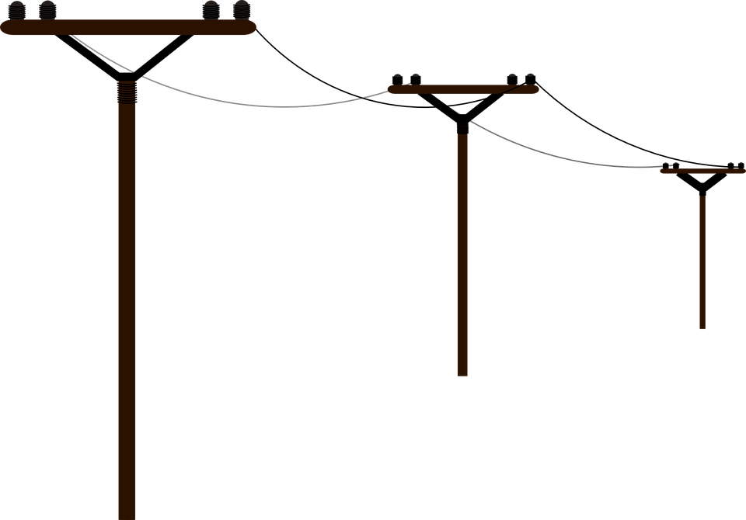
CUSTAR ELECTRIC DEPT/
BOARD OF PUBLIC AFFAIRS

President Jerry Clink
Vice President Dave Wensink
Board Member Deb Bechstein
Clerk Barb Clink

For questions, electrical hookup,
or repairs, call 419-669-3537

BAGWORMS
Be on the lookout for bagworms, as they’ve started to take over several trees in our little Village. These destructive insects, whose cocoons look similar to pinecones, attach themselves mainly to evergreens and other conifer varieties. Hatching generally happens in late May or early June, after which they begin munching their way through the tree and killing it. The best way to prevent this is to spray your trees with an insecticide that contains malathion, diazinon, or carbaryl. You can also clip the cocoons from the tree and put them in a bucket of warm soapy water.

FOOD PANTRY CABINET
Thank you to everyone who has been so faithfully stocking and restocking the new food pantry located at the recycling building. We appreciate that St. Louis Church has generously started this service for those in the area to use when they are in need.
CLOTHING BIN
Before you take your old clothing at Goodwill, consider putting your items in the bright green drop box located next to our recycling bins. With garage sales coming up, we hope you’ll use this to dispose of any of your un-solds.

The following items are accepted (and can be put in tied plastic bags):
- Clothes such as shirts, pants, jeans, skirts, dresses, suits, shorts, etc
- Outerwear such as coats, jackets, gloves, hats, & scarves
- Footwear such as shoes, boots, heels, sneakers, sandals, & socks
- Undergarments such as bras, underwear, slips, hosiery, & camisoles
- Linens such as towels, sheets, comforters, blankets, & tablecloths
- Accessories such as hats, belts, ties, scarves, headbands, purses,
wallets, totes, luggage, & backpacks

Your items will be recycled in an earth-friendly fashion and the Village receives 7 cents per pound for all collections. Everyone wins!

CODE RED ALERT SYSTEM
If you haven’t already, be sure to sign up for CodeRed alerts. You can do this by clicking on the link on the front page of our website (custarvillage.org). This will allow you to receive important messages about emergencies, weather, outages, and other community updates.

For more information, visit our website at www.custarvillage.org. Also feel free to attend Council’s monthly meetings, the 2nd Wednesday of every month at 7:30pm at the Legion Hall on Custar Rd. To contact the Village at any other time, call Mayor Rob Cavin at 419-614-4026 or email custarvillage@gmail.com.

THIS NEWSLETTER WAS BROUGHT TO YOU BY YOUR CUSTAR LOCAL OFFICIALS:
Mayor Rob Cavin; Council President Renee Hartman; Fiscal Officer Sarah Schroeder
Village Council- Cheryl Vanscoder, Chad Dauster, Dee Bates, Dawn Berry, & Jeff Dauster

